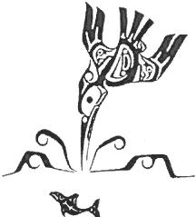
PO Box 340 Port Alberni, BC V9Y 7M8 Tel.: (250) 745-3333 Fax: (250) 745-3332
Toll-free 1-888-745 -3366 Email: executivedirector@ditidaht.ca

April 30, 2020

The public health emergency has been extended to May 12th. Please continue to practice social distancing; and please, if at all possible, stay home. We encourage everyone to stay home so we can flatten the curve.

Ditidaht will continue to monitor the entrance of the reserve to ensure no visitors or tourists come into the community. Thank you everyone for cooperating with this order to keep everyone safe at this time.

We heard from Indigenous Services Canada, and they confirmed through a telephone call, that there was many applications for the Urban Indigenous Funds, and they approved 94 proposals. Unfortunately, Ditidaht First Nation was not on the list as an approved proposal. We encourage members to seek assistance through your local Friendship Centre or food bank during this pandemic.

Ditidaht has continued to do the food fish and please watch for updates on delivery.

Thank you for Ditidaht staff and volunteers for your commitment to continue working on food distribution, food fishing and monitoring the reserve.

Take care everyone.

